Development of slant-high resolution Software Defined Radar (SDRadar) target detection system using LabVIEW

Prashanth Kumar Bejjarapu
Electronics and Communication Engineering
B. V. Raju Institute of Technology
Medak, Telangana, India
culkid26@gmail.com
Dr. B. R. Sanjeev Reddy
Electronics and Communication Engineering
B. V. Raju Institute of Technology
Medak, Telangana, India
sanjeev.reddy@bvrit.ac.in

Abstract—This project proposes a prototype developed for obtaining precise slant high resolution with software defined radar (SDRadar) target detection system using LabVIEW. Initial phase of the project includes quantitative analysis of the parameters associated with target system and SDRadar. The major parameters include bandwidth enhancement, high signal to noise ratio (SNR), operating frequency, down range, slant range and number of pulses which is performed using LabVIEW software. Stretch processor and Doppler shift algorithms are proposed for obtaining the best slant high resolution and both are compared. Fast Fourier Transform (FFT) technique is used as transformation tool for both the algorithms proposed.
Keywords— SDRadar, Slant high Resolution, SNR, Bandwidth enhancement, FFT.

Introduction
Radars are specifically used in most applications including military applications, surveillance projects, target detection and tracking the distance of the target, determining the range resolution and the bandwidth enhancement. Radars cost is also high according to its requirement in the project. For satisfying the requirements, a latest technology evolved in the radar technology, i.e., Software Defined Radar abbreviated as (SDRadar) is used in the project. This type of low cost radar is used for determining the parameters such as, Bandwidth enhancement and the slant range resolution, increasing the signal-to-noise ratio (SNR). Stretch Processor and Doppler shift Algorithms are used in this SDRadar and Fast Fourier Transform (FFT) is used as the transformation tool for the algorithms proposed. The whole setup is controlled by using the LabVIEW application and the graphical representation of the results is shown in the following sections. [7]
These radars can be useful to design software defined radar which will be able to design the following:
- Multifunctional radar
- Re-using the same hardware
- Advanced signal processing algorithms
- Reduced price
- Faster development
Multifunctional radar can be designed by using by considering the antenna and processor speed. The antenna is considered which has to be used for transmitting and receiving antenna and processing speed has to be high in which graphical user interface boards is used with USRP transceivers.
In the first-generation radar, blocks used for designing might be costly and those blocks can be used in further development of software defined radars. So, these blocks can be used in other applications where cost is reduced because of the existing hardware. Only software has to be changed for every application.
In radar technology, researchers have developed many algorithms and tested new advanced signal processing algorithms. Some of them include Space Time Adaptive Processing (STAP), Synthetic Aperture Radar (SAR), Inverse Synthetic Aperture Radar (ISAR) is developed in the computer but in real world, processing can be done by adapting specialized hardware circuits.[7]
The possibility of using the blocks from the previous radars and using in the new radar leads to the faster development and the cost of radar designing also reduces as many of the blocks is already arranged from the previous radar application. Hardware parts is already existing and only task is to develop the software part for designing software defined radar.
Additionally, the possibility of testing the radar which is under development by taking the algorithm in which no prototype is required. This will allow faster and reduction in the price is obtained. Overall, the creation of multifunctional radar reduces the cost when compared to the building of individual systems individually for different applications.

Designing the system

Existing SDRadar System
In existing SDRadar, target detection is carried out by the strength of the signal received to the receiver antenna. The SDRadar uses large frequencies and bandwidth range is limited up to 2MHz to 25MHz. Input signal and the local oscillator signal is allowed into mixer and then allowed into the low pass filter. FFT is used as the transformation technique for converting the signals into time-domain frequency components.

Proposed System
The motivation to take this project is to develop the slant range resolution [6] and to enhance the bandwidth enhancement, increase the signal to noise (SNR) ratio. The block diagram of the proposed system is given below. It contains the various blocks, such as, Single Board Computer, USRP board, Power amplifier, Low Noise amplifier, Circulator, Motor, Controller and the Antenna.
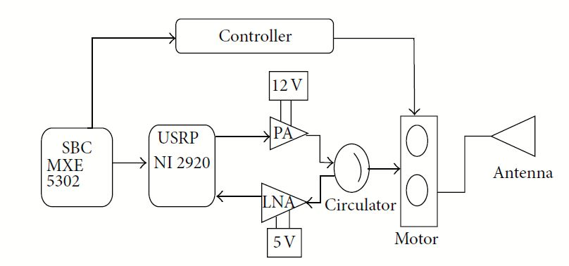
FIGURE 1: Block diagram of the proposed SDRadar system
A single antenna is provided in the system which is used for transmitting and receiving the signals. A single board computer is used in this system to control the motor using controller. USRP N210 board is used in this system and it uses various algorithms for target detection. Power amplifier is used in the transmitter path which operates with the voltage of 12V and low noise amplifier is used to clear the noise components which is added in the receiver signal while receiving at the antenna. Circulator is used to adapt the usage of single antenna which acts as both transmitting and receiving [6]. DC motor is used in the system to scan the target in various directions which is operated by the controller. The whole setup is controlled by the LabVIEW application from computer.

Stretch Processing Algorthm
Stretch Processor Algorithm is implemented in this SDRadar for the signal processing. It contains the various stages in the block diagram in figure 2.
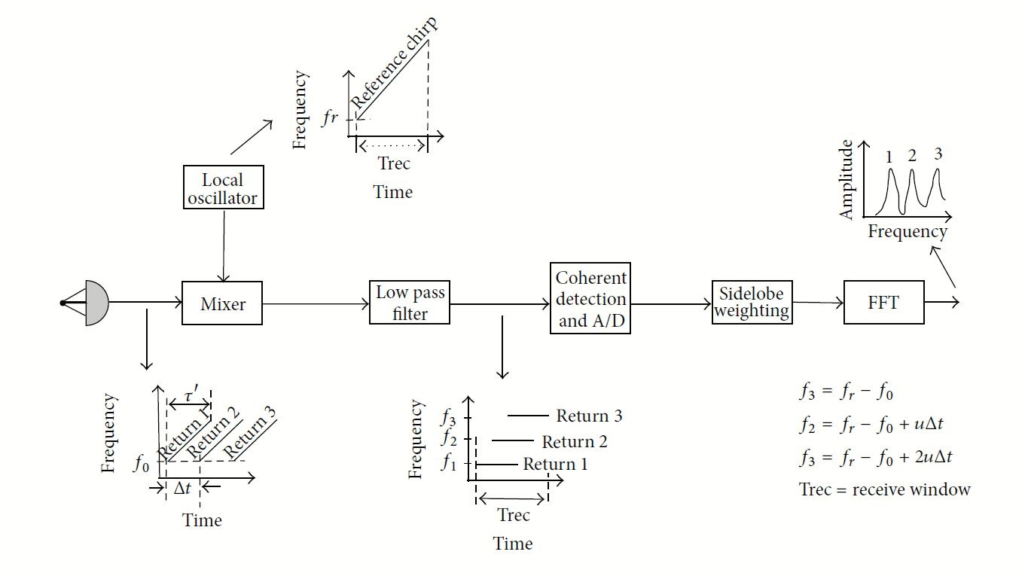
FIGURE 2: Block diagram of Stretch Processing Algorithm
The transmitting signal is a linear frequency modulated waveform expressed in the equation as
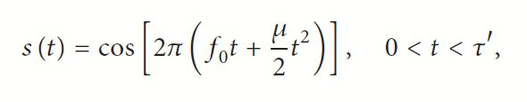
where f₀ is chirp start frequency, t is time period, 𝛍=B/τ` is the LFM co-efficient and τ` is the chirp duration.
The transmitted input signal is added with the local oscillator signal in the mixer block which produces the addition and the subtraction of the frequency signals, then the transmitted signal is given to the low pass filter block which do not allow the higher frequencies above the cutoff frequency. After passing through the low pass filter block, the signal is passed into Fast Fourier transform and peaks is observed from the FFT Output. The waveforms of every block is represented in the Figures.
The slant range resolution value can be found out by using the following equation
ΔR = c/2B
Where B represents the Bandwidth and c is the speed of the light. By using this algorithm, the range resolution can be found out. In the existing system, USRP NI2920 kit is used and it produced the results when the outdoor setup is implemented to 6m. This project helps to increase the range resolution value less than 6m.

Simulation results
Experimental setup can be verified by using both indoor and outdoor. SDRadar setup is placed outside and metal plates are arranged at a distance and the signal is allowed to touch the target and receives the echo signal. Based on the received echo signal, the target distance can be found out in meters. This SDRadar can be used to detect the targets which is present in the airborne navigation also. In this work, high frequencies up to 2MHz is given in input frequency and local oscillator frequency is chosen greater than the input signal frequency.

Input Signal waveform in Fig. 3
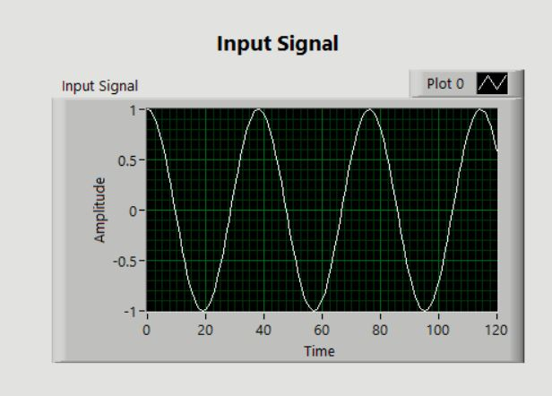
FIGURE 3: Input Signal
The input signal is added with the local oscillator signal shown in Fig. 4
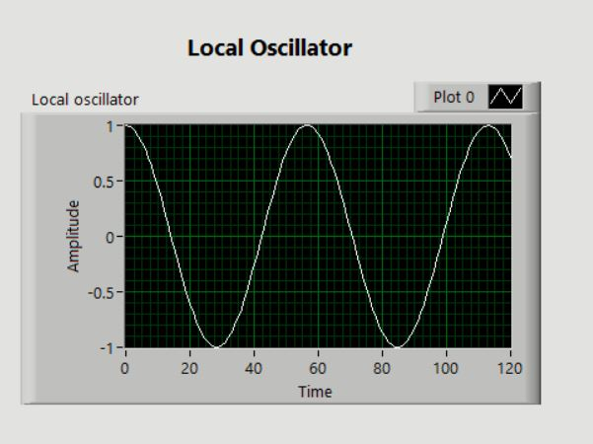
FIGURE 4: Local Oscillator Waveform
Input signal and the local oscillator signal is allowed into the mixer block and the frequencies added and subtracted shown in Fig. 5 and Fig. 6.
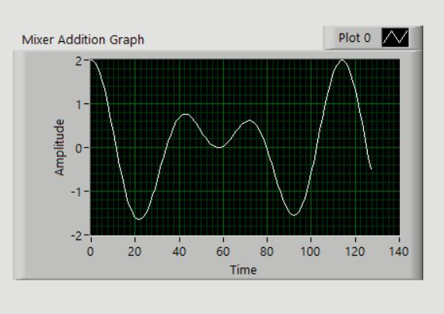
FIGURE 5: Mixer addition graph
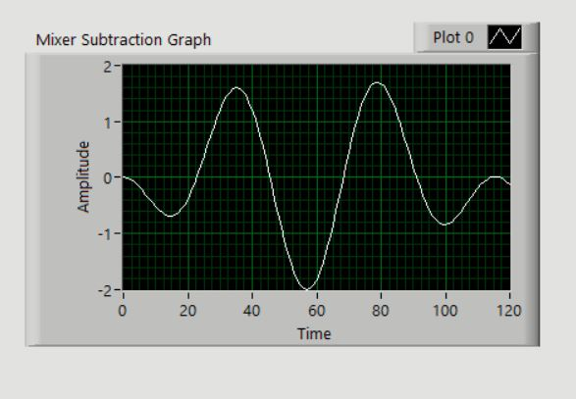 FIGURE 6: Mixer subtraction graph output
The outputs of the mixer (addition) is given to the low pass filter block and its output is shown in Fig.7.
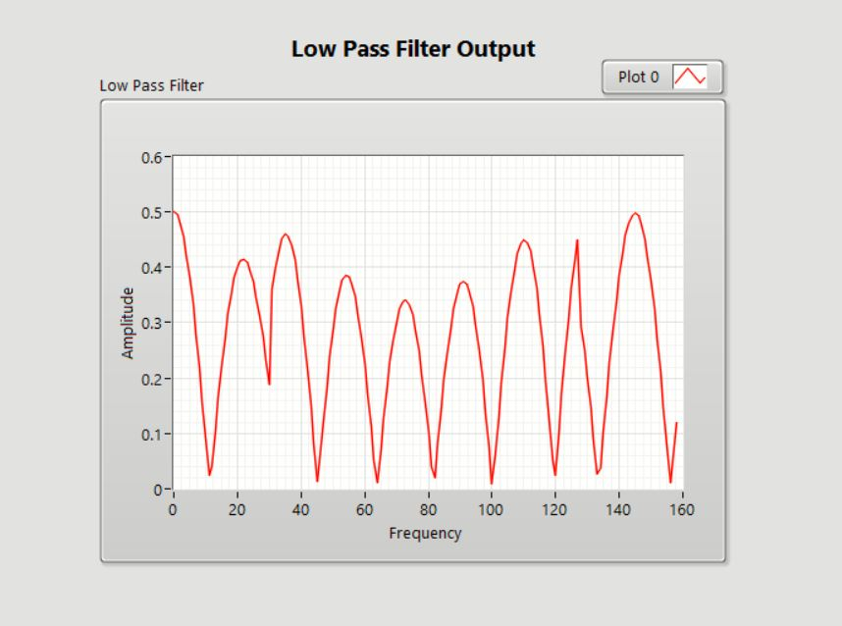
FIGURE 7: Low Pass Filter waveform
The output of the low pass filter is given to the transformation technique FFT is shown in Fig.8.
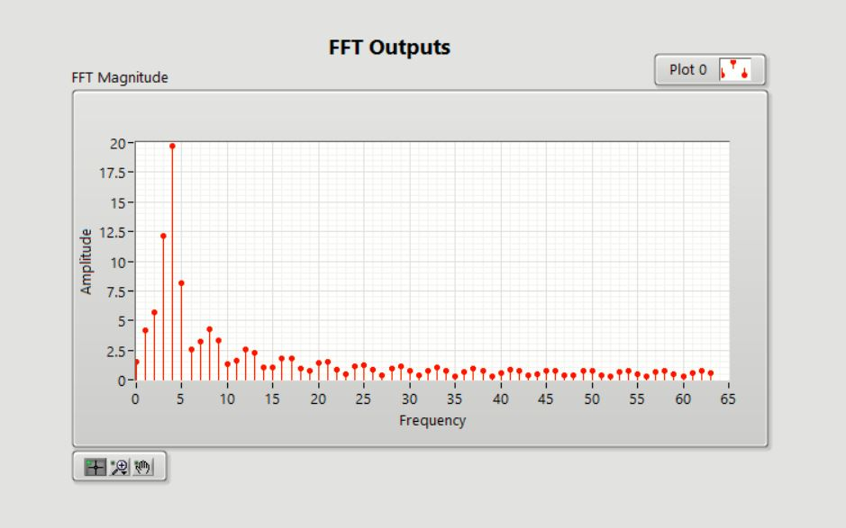
FIGURE 8: Fast Fourier Transform Output
The above figures represent the lower and higher frequencies and their fast fourier transform outputs. Same work is carried out for the frequencies starting from the range 0 to 2 MHz and all the FFT outputs frequency is plotted against the frequencies.
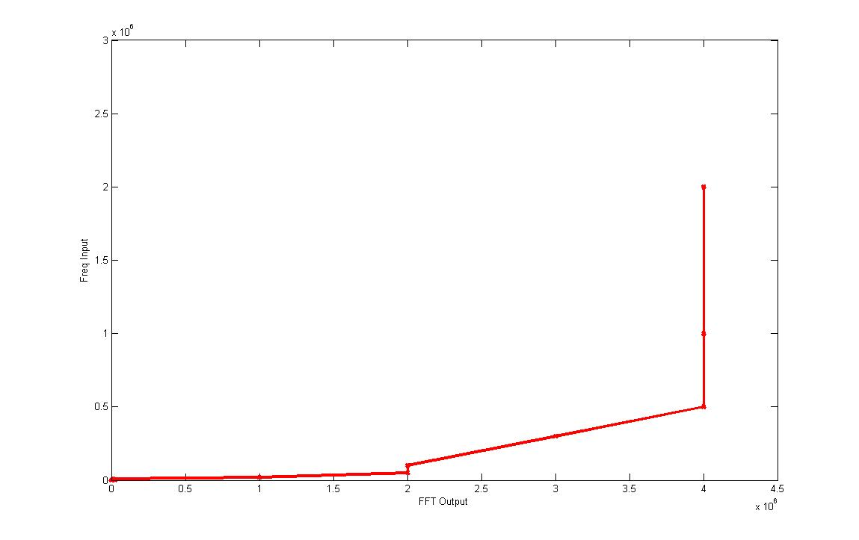
FIGURE 9: FFT values over different frequencies
The above Fig. 9 represents the values for whose frequencies is raised and fast fourier transform of each frequency is observed and plotted against the frequency. The range is given up to 2 MHz and it is constant at showing FFT outputs constantly on 4 MHz.
Range resolution can be found out by using the formula
𝛥R = c/2*B (1)
Where c is speed of light (3x10⁸ m/s) and B is Bandwidth of the frequency. By above simulation results, Bandwidth B, is calculated from the FFT output waveform, which results in 50MHz.
Apply these values into Eq. (1) and range resolution value is given with 3m, which reduced from 6m.

CONCLUSION
The limitations on the bandwidth is resolved in this implementation of the SDRadar. The project has the ability to reduce the slant range resolution from 6m to 3m. The limitation on the low-cost and the low data rate availability limits the potential use of the SDRadar. These SDRadar can be used in many applications and slant range resolution value is decreased by using the low cost SDRadar. In this work, the new generation USRP N210 has been investigated to design a low cost SDRadar and strongly improving the bandwidth enhancement and the slant range resolution when compared to the other radar [4].
To monitor the operations of SDRadar, a specific LabVIEW code is developed to use the signal processing algorithm and takes command over all the blocks present in the system. The motto of this work is to increase the slant range resolution and experimentally can be proved by outdoor and indoor tests.
Limitation of this project states that it operates on the micro frequencies but not on nano frequencies. Algorithms can be developed for the SDRadar which operates on the nano frequencies.
As a future extension of this project, work can be carried out on designing the new supplementary algorithms on SDRadar. For example, doppler shift frequency analysis is carried out to find if the target movements in motion. So, new functions can be carried out on the same platform without changing the design, in order to create a simple, low cost and multifunctional SDRadar.

Acknowledgment
Authors are very much thankful to the Advanced Communication Laboratory, Department of ECE, BVRIT Medak for giving us the opportunity to use the resources of the department and also the support from team members of ACL.

References

- T. Debatty, “Software defined RADAR a state of the art.” In Proceedings of the 2nd International Workshop on Cognitive Information Processing(CIP’10),pp.253-257, Brussels, Belgium, June 2010.
- C. Prathyusha, S. N. Soumiya, S. Ramanathan, “Implementation of a low cost synthetic aperture radar using software defined radio,” in Proceedings of the 2nd International Conference on Computing, Communication and Networking Technologies (ICCCNT’10),Karur, India, july 2010.
- M.Fuhr, M.Braun, C.Sturmz, L. Reichardtz, and F.K. Jondral, “AN SDR based Experimentakl setup for OFDM based radar,” in Proceedings of the 7th Karlsruhe Workshop on Software Radio”,Karlsruhe, Germany, march 2012.
- V. Fernandes, “Implementation of a RADAR System using MATLAB anf the USRP,” CSUN ScholarWorks, 2012.
- B. R. Mahafza and A. Z. Elsherbeni, Simulations for Radar Systems Design, Chapman & hall/CRC, Newyork,NY, USA, 1999.
- S. Costanzo, F. Spadafora, A. Borgia, H. O. Moreno, A. Costanzo, and G. Di Massa, ”High Resolution Software Defined Radar System for Target Detection,” August 2013.
- Fabian L, Victor W, "Radar Target Altitude Measurement," sweden, 2013.

